1. **INTRODUCTION**
   1. *overview*
      * *Description of the project*

Project Description:

UrbanAura Interiors , a Interior Designing company uses Zoho books to effectively manage their financial processes, maintain accurate records, and make informed financial decisions. This integration enhances their overall business efficiency and contributes to their success in the interior design industry.

* 1. **PURPOSE**

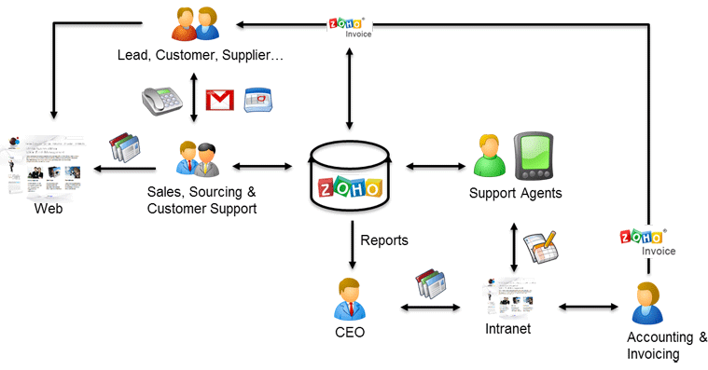

1. **Problem definition & design Thinking**
   1. *Empathy map*

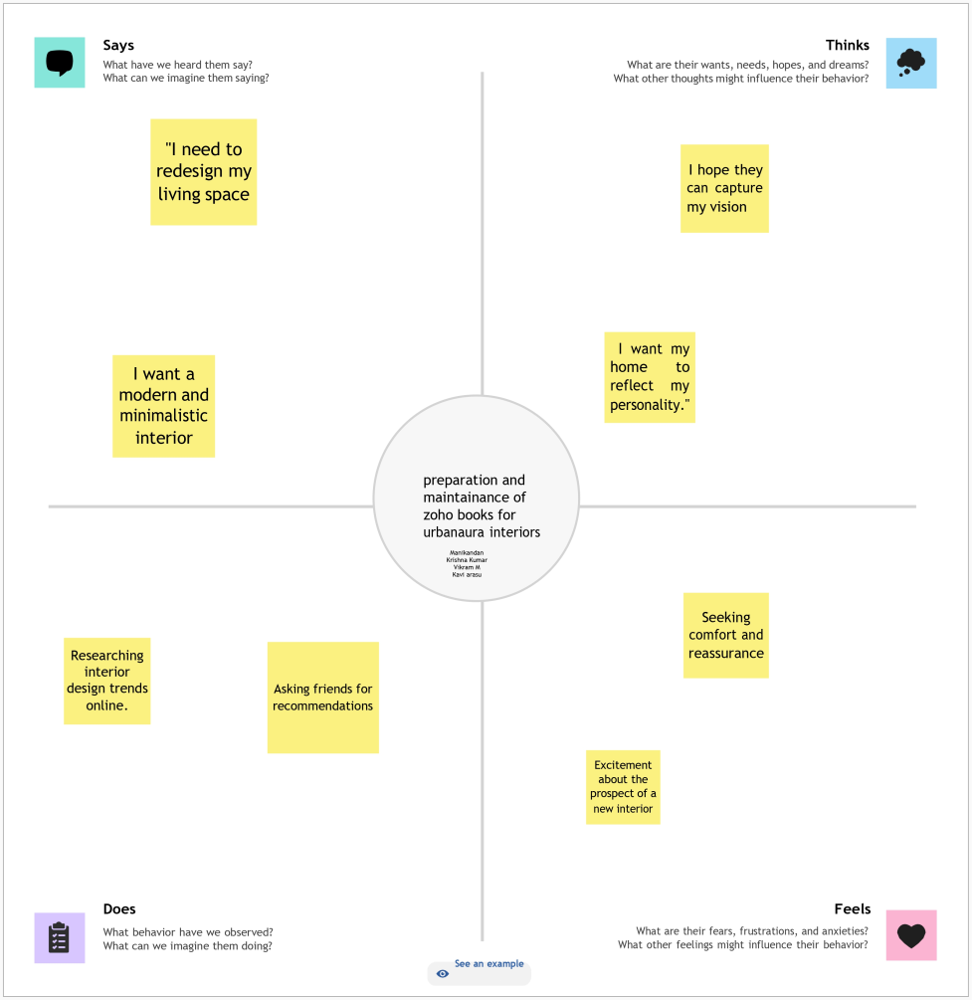

*BrainStorm:  
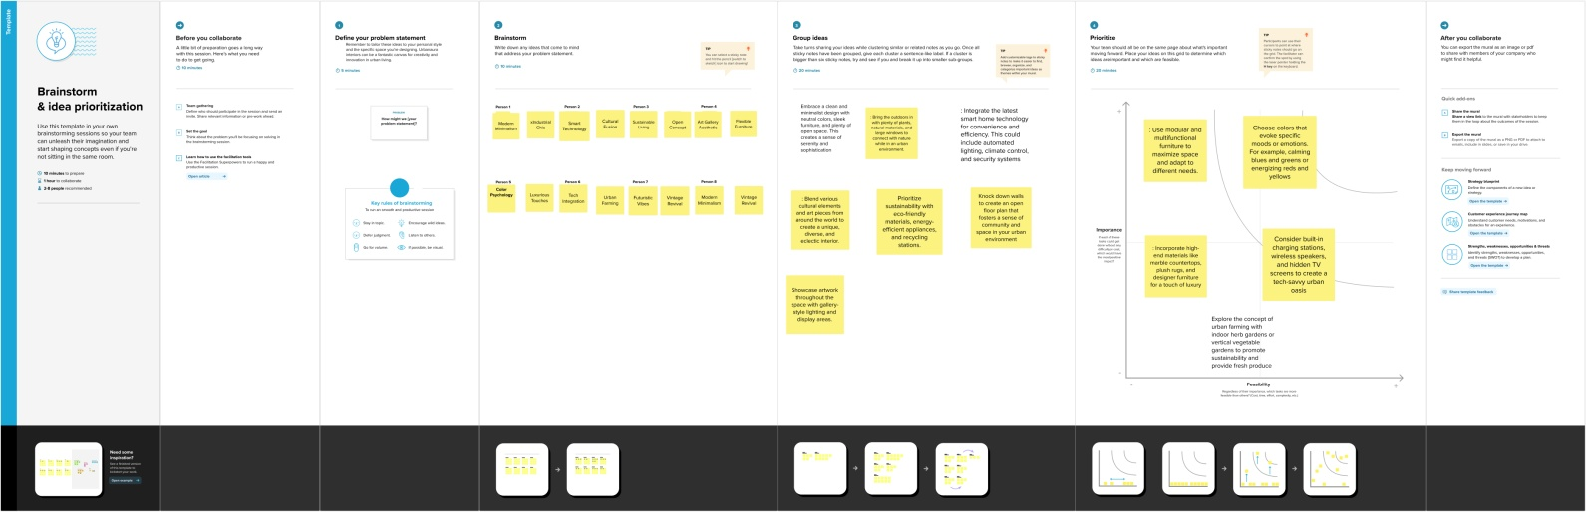*

1. **Result Profit&loss**

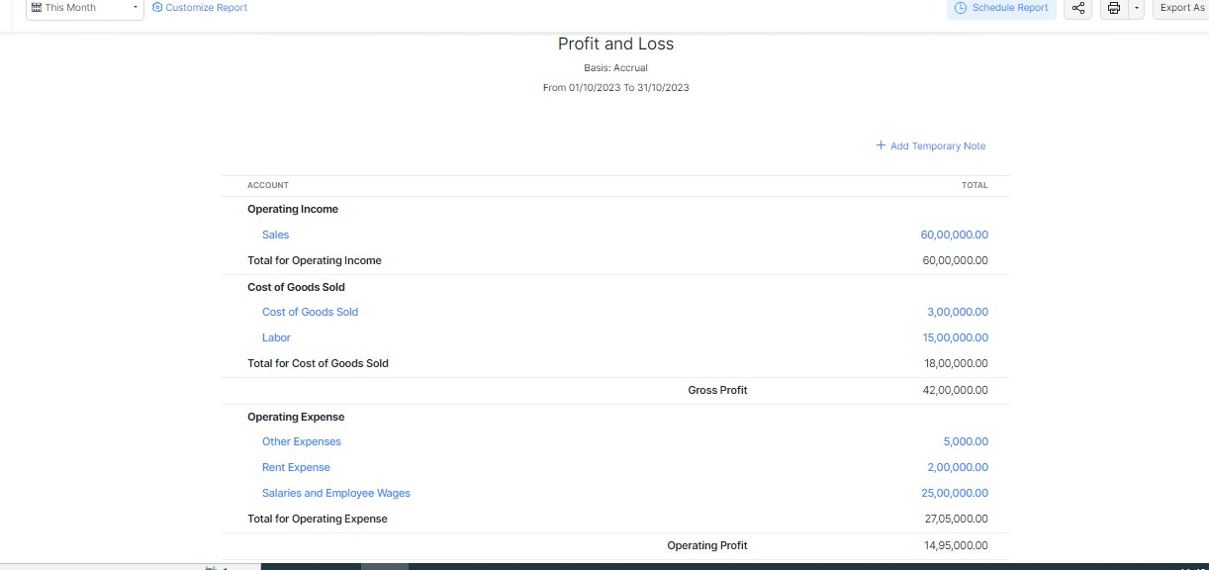

Purchase order:

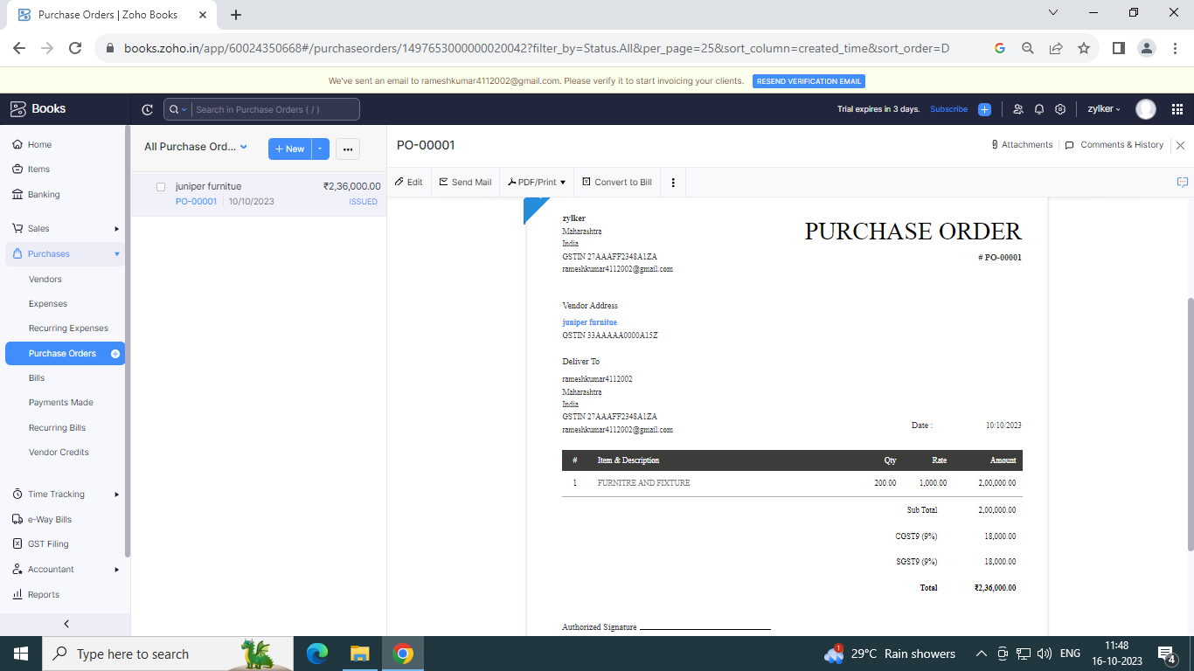

ADVANTAGES OF URBAN AURA INTERIORS:

* (i) An urban location is well-connected with different modes of transport.
* (ii) If offers excellent facilities for communication.
* (iii) Power and water supplies are easily available.
* (iv) Facilities for repairs and maintenance are better.
* (v) The adequate supply of unskilled and skilled labour force is available.

DISADVANTAGES OF URBAN AURA INTERIORS:

* (i) Cost of land and construction of building on it is high.
* (ii) Land suitable for a large-scale unit is difficult to get and is usually, limited in the area; if available.

1. *APPLICATIONS:*

URBAN AURA INTERIORS.

1. **Conclusion:**

Inadequate healthcare is prevalent globally in all countries, and no country has a perfect healthcare system.

APPENDIX

https://drive.google.com/file/d/1auuK_3XIAYhV_9fCh2mX1DzSHgPE4asa/view